**Project Design Phase-II**

**Data Flow Diagram & User Stories**

|  |  |
| --- | --- |
| Date | 28 June 2025 |
| Team ID | LTVIP2025TMID54300 |
| Project Name | **ShopSmart** |
| Maximum Marks | 4 Marks |

**Data Flow Diagrams:**

A Data Flow Diagram (DFD) is a graphical tool that helps visualize how data moves through the ShopSmart system. It represents the flow of information between different modules like user interface, backend services, database, and admin portal. DFDs are essential for understanding system functionality at a glance and ensuring clear communication between developers and stakeholders.

**Example Structure in ShopSmart:**

* **Users** (customers/admins) send requests (login, browse, add to cart, etc.)
* **Frontend** captures input and communicates with backend via APIs
* **Backend** handles authentication, product logic, order placement, and admin control
* **Database (MongoDB)** stores user data, product listings, orders, cart, and feedback
* **Admin Portal** retrieves/manages data from the backend for inventory and order handling

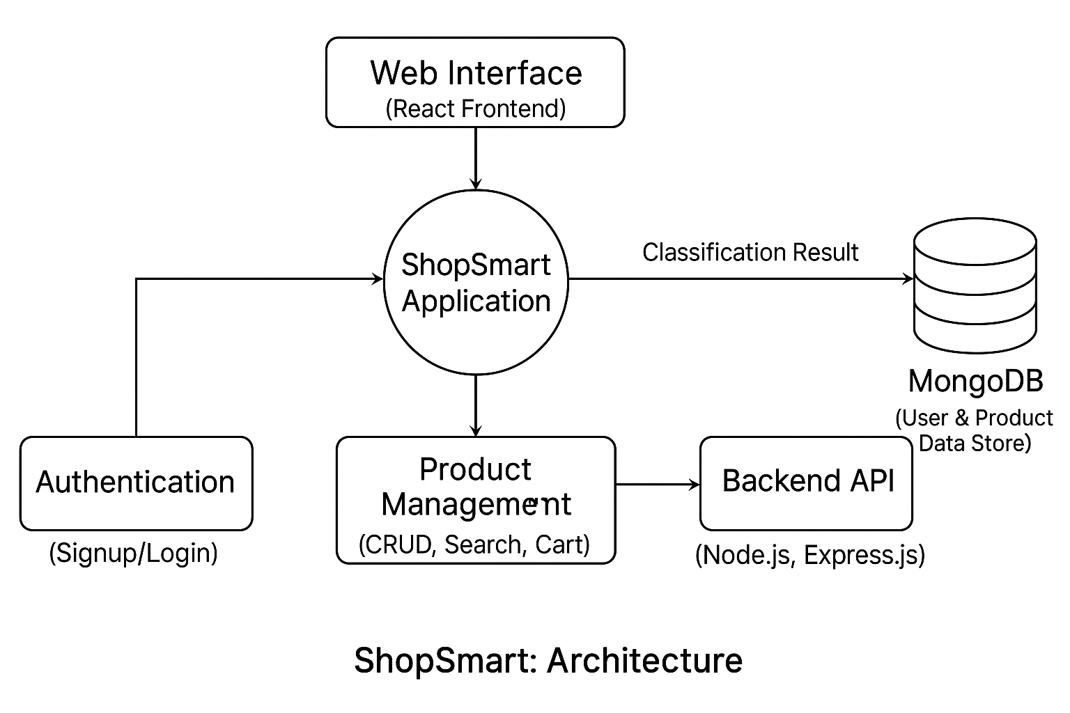

**User Stories**

| **Sprint** | **Functional Requirement (Epic)** | **User Story Number** | **User Story / Task** | **Story Points** | **Priority** | **Team Members** |
| --- | --- | --- | --- | --- | --- | --- |
| Sprint-1 | User Registration & Authentication | USN-1 | As a user, I can register and log in securely using JWT for protected access. | 3 | High | Shaik Seeza Samreen |
| Sprint-1 | Product Catalog | USN-2 | As a user, I can browse products with name, image, price, and category tags. | 3 | High | Shaik Muzammil Hussain |
| Sprint-1 | Search & Filter | USN-3 | As a user, I can search and filter products by category or price. | 4 | High | Shaik Abdul Hafeez |
| Sprint-2 | Cart Functionality | USN-4 | As a user, I can add, remove, and update items in the shopping cart. | 3 | High | Shaik Seeza Samreen |
| Sprint-2 | Order Placement | USN-5 | |  | | --- | |  |  |  | | --- | | As a user, I can place an order and receive a confirmation once it's placed. | | 4 | Medium | Shaik Irfan |
| Sprint-2 | |  | | --- | |  |   Payment Integration | USN-6 | As a user, I can make online payments via Razorpay or UPI. | 5 | High | Shaik Muzammil Hussain |
| Sprint-3 | Order Tracking | USN-7 | As a user, I can view my order history and track order status. | 2 | Medium | Shaik Seeza Samreen |
| Sprint-3 | Admin Dashboard | USN-8 | As an admin, I can add/edit/delete products and manage orders and feedback. | 4 | High | Haik Abdul Hafeez |
| Sprint-3 | Product Recommendations  (Future Scope) | USN-9 | As a user, I can get product suggestions based on my interests and past behavior. | 3 | Low | Shaik Irfan |
| Sprint-3 | Final Testing & Deployment | USN-10 | As a team, we want to test all modules and deploy the working app to production. | 3 | High | All Members |